Exercise#2

1. Using *man* describe the following.

|  |  |
| --- | --- |
| pwd | prints the name of current/working directory |
| ls | lists directory contents |
| ls -a | do not ignore entries starting with |
| ls -l | do not list implied entries matching shell PATTERN |
| mkdir | makes a new directory |
| rmdir | removes empty directories |
| cp | copy files and directories |
| cp -i | prompt before overwrite (overrides a previous -n option) |
| rm, -r and -f | remove files or directories.  -r:- remove directories and their contents recursively.  -f:- ignore nonexistent files and arguments, never prompt. |

1. Type the following commands one by one and press Enter
   1. whoami
   2. ls
   3. Create the directory abc, abc1 and abc2 in your home folder
   4. ls
   5. mkdir -p test/test1/test2
   6. tree test

Paste the screenshot here.

1. Type the following commands one by one and press Enter
   1. whoami
   2. touch file1.txt
   3. cat file1.txt
   4. echo “I love Linux and support the open-source software.”
   5. echo “I love Linux and support the open-source software.”>>file1.txt
   6. cat file1.txt
   7. what is difference between who and whoami? Paste the screenshot here.

The difference between who and whoami is who shows the username of current logged in user and whoami shows the user information.

1. Type the following commands one by one and press Enter
   1. date
   2. date +%m/%d/%y
   3. date +%H:%M:%S
   4. set the system time using time clock utility (hwclock) Paste the screenshot here.

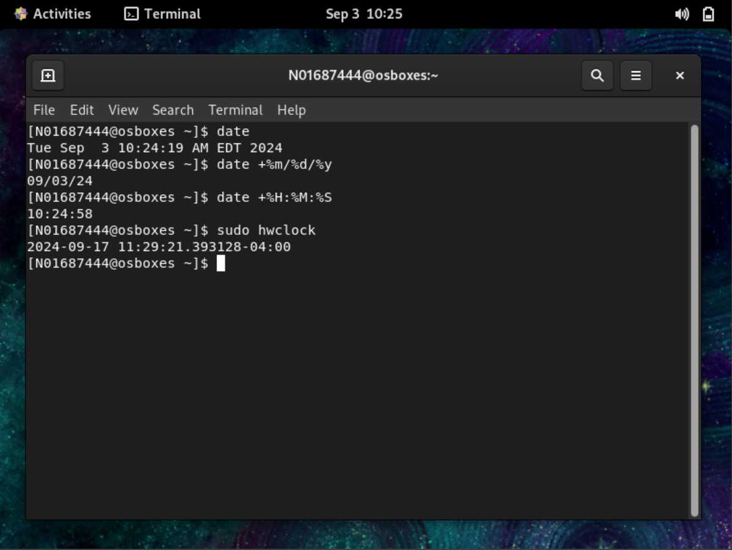

1. Type the following commands one by one and press Enter
   1. ls -l
   2. ls -al
   3. ls -alt

Observe the output of above commands and reflect.

Ls -l shows the list of all the directories.

Ls-al shows the list of the directories including system directories.

Ls-alt it works same as ls-al but there is some added information in this.

1. Redirect the history to file “his17Sep24”.

Issue the following command and note down your observations.

* 1. Cat his17Sep24
  2. more his17Sep24
  3. less his17Sep24
  4. What is difference between more and less. Paste the screenshot here.

The difference between more and less is more has : forward navigation and limited backward navigation and less has both forward and backward navigation and also has search options.